Flowchart

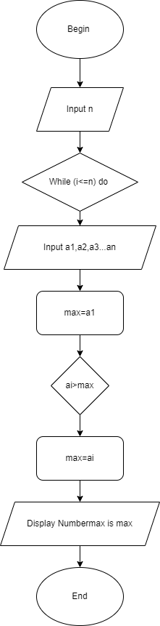

pseudo-code

Begin

Input n

While (i<=n) do

Input a1,a2,a3...an

end do

max=a1

While (i<=n) do

if ai>max then

max=ai

end if

end do

Display Numbermax is max

End